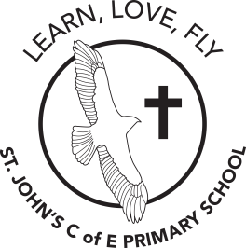
St John’s C of E (Aided) Primary School
Grove Road, Gosport, Hampshire PO12 4JH
www.st-johns-gosport.hants.sch.uk
adminoffice@st-johns-gosport.hants.sch.uk

Headteacher: Mrs Carolyn Wilkinson
Deputy Headteacher: Mrs Gemma Havey
Schools Business Manager: Mrs Hannah Bonwick Telephone: 023 9258 2404

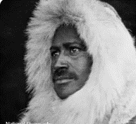
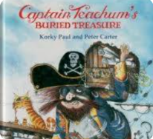
Year 1 Spring 2 2026

Dear Parents,

Welcome back everyone. We hope you had a lovely break and the children are ready for another exciting half term.

English Topics

Children will be focusing their writing around the explorer Matthew Henson. They will be learning facts and creating sentences all about his adventures to the North Pole. As the children have a strong imagination and interest in Pirates, our next topic will be focused around the text Captain Teachum.
The children will be orally retelling the story and writing sentences to describe the character.

World Book Day Friday 6th March
Your child will need to come to school on this day dressed as their favourite book character. This year our World Book Day theme is around books by the author Paul Geraghty. The children will be doing a range of activities based on one of his texts as we are lucky enough to have this author and illustrator visit school on Friday 27th February.

English – Factual sentences about a famous explorer and descriptive sentences about the character Captain Teachum.

Maths – Multiplication and division and place value

Science – Plants
History – How have explorers changed the world?
PE – Inside- Gymnastics: Body Parts
RE – Salvation – The concept of Welcoming in the Easter Story

DT- Making puppets
Music - Musical Vocabulary – Keeping the Pulse: My Favourite Things
Computing – Digital Imagery
PDL Jigsaw and No Outsiders – Healthy Me

Indoor PE – This will continue to be on a Wednesday this half term. Children should wear PE kit to school on this day.

Library Day – Monday- children should bring their Library book back on Monday to return and change.

Uniform
As the weather starts to improve, children may be taking off jumpers/cardigans at varying times throughout the day. Please make sure your child’s clothes are named to ensure that if they leave them elsewhere in the school, they will work their way back to us.

Water Bottles, Bookbags and Little Wandle Books
Please ensure your child is bringing a named water bottle into school each day as the weather improves. The children do need their bookbag every single day as we record in their reading diaries and their certificates are really important to them. Little Wandle books need to be returned to staff every Monday, so that they can be used for other groups. We have noticed that some books have been ruined through water bottles being placed in book bags. Please make sure that bottles are carried separately to avoid this happening.

Independence
As we try to foster greater independence as they move towards Year 2, we are hoping that with our reminders the children will remember everything they need to bring to school and to go home with. Over Spring 1 we noticed that a lot of children have been returning to the classroom at the end of the day, when there could be no adults present to supervise them. For their safety please keep the children with you once we have handed them to you. Many thanks for your support with this.

Thank you for your continued support

Mrs Campbell, Mrs Bailey, Miss Green and the Year 1 Team

