Early Years Spring 2
Dear Parents,

Welcome back everyone and we hope that you have enjoyed your half term break. This half term our topic will be ‘FOOD’. We will be looking particularly at two different food stories which are:
Little Red Hen Oliver’s Vegetables Easter Story
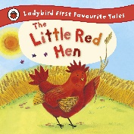
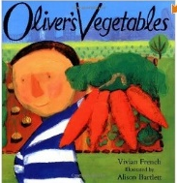
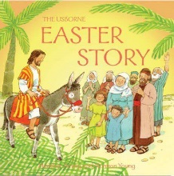

There is a link to these stories on our website in the Early Years section for you to watch as a family at home. The final two weeks of the half term we will be focusing on Easter and the Easter Story.

Phonics
For this half term we will be focussing on the following letter sounds and words:
Recapping: ai, ee, igh, oa, short and long oo, ar, ur, ow, oi, ear, er, air
Words with 2 digraphs, longer words and words ending in ing and compound words such as carpark, bedroom. We will also be looking at words ending in e and es.

You will still hear your child talking about digraphs. This is when 2 letters make only 1 sound for example sh in shop so this word has only 3 sounds (phonemes) sh o p despite having 4 letters. You may even hear them talk about trigraphs – 3 letters making 1 sound – light = l igh t.

We are continuing to recap our new sounds (there are 44 in total) and we are applying these to simple words for use in our reading and for when we are writing simple sentences, captions and labels. Please let us know if we can support you with this as we do not want the children’s progress to slow down or for them to have gaps in their learning.

Reading
The children in school continue to impress us with their developing reading skills and are very much in the routine of reading with us three times a week in the Guided Reading sessions. Please remember to record your child’s reading each night in their reading diary as they are all working towards certificates and prizes. Book bags are needed in school daily.

World Book Day- Friday 6th March 2026
The day is a worldwide celebration of books and reading. Children can come to school dressed as a book character- Keep your eye on the newsletter for more information.

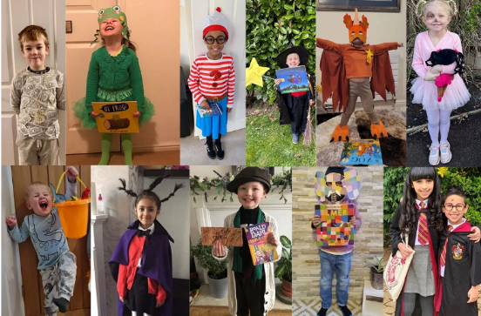
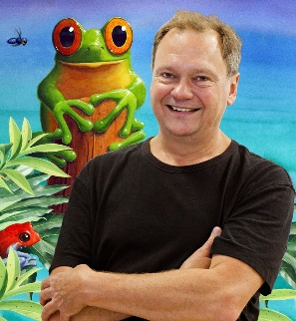


Library
We will continue to use the library on a Tuesday afternoon. We recommend storing library books in children’s bookbag so that they never forget it.

Uniform
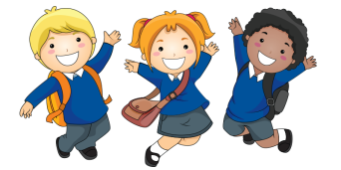
It is always lovely to see the children looking so smart and ready to learn. With the new half term and the children’s growth, you may have had to buy some new items of clothing for school. May we take this opportunity to remind everyone to make sure that everything is named including shoes if possible! Thank you for your help with this. Also, if you wish to donate any old clothes, they are always very useful in school including clean pants, socks and tights for when we have the occasional accident. If you have any uniform that we have lent you after an accident etc. please can you make sure it is returned to school.
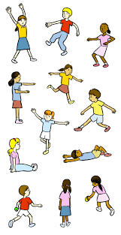
PE
This is a really fun session that all the children look forward to. We will continue to practice our travelling and high and low shapes but we will now be introducing jumping, balancing and apparatus - going over, under and through these safely. We will extend the children’s thinking into building up our own sequences. They will need to be in PE kit on a FRIDAY.

Woodwork
With woodwork, the biggest challenge is keeping up with demand. We would very much like to encourage you to help out by bringing in any offcuts of NON-TREATED soft wood such as pine and other resources such as bottle tops, corks, and lids. As children become eager makers and creators, we will need on-going help with this! Thank you.


Sir Harold Hillier Gardens
This is just a reminder that we are very excited to be visiting Sir Harold Hillier Gardens on Friday 3rd July 2026. If you have not yet paid or completed the permission slips, please could you do so. Please find the link to the form below and payment can be made via Arbor or with cash at the office. Please note that the office is unable to give change.
The cost is £30 per child. We will send a separate letter closer to the date with more information about the visit.

https://forms.office.com/e/23CTVsaigW

Thank you again for your support and we all are looking forward to working with you this term.

Mrs Dickinson, Miss Hiseman and team

