 | Week 1 | Week 2 | Week 3 | Week 4 | Week 5
Enquiry Theme | Little Red Hen  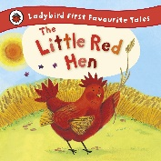 |  | Oliver’s Vegetables  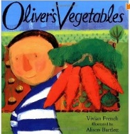 |  | Hot Cross Buns  Easter  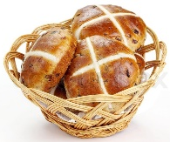
PDL   | Blue Chameleon  LO: make a new friend  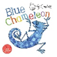 |  | Christian Value: Love  Six Strands: Respect  I can help others with support.  I can wait my turn with support.  I can tidy up with support.  I can accept when my turn finishes with support.
Drawing Club  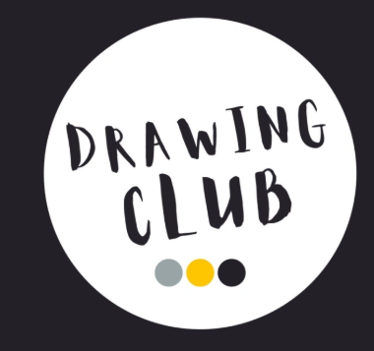 | Tales from the past  Banana Man   | Traditional Tale  Little Red Hen  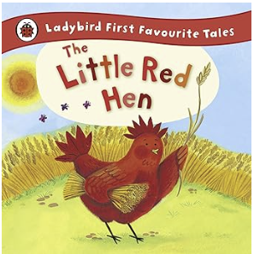 | Adventure Story  Oliver’s Vegetables  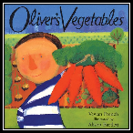 | Tales from the Past  Poddington Peas  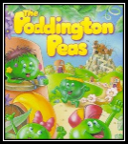 | Traditional Tale  The Enormous Turnip  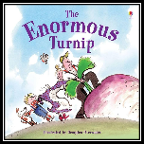
RE    Theme: celebrations | Communicate  LO: Communicate their feelings about celebrations of new life. | Apply  LO: Listen to others and share their feelings about celebrations | Inquire  LO: Identify what a celebration is. | Contextualise  LO: Engage with ways that Christian’s celebrate new life at Easter. | Evaluate  LO: Respond to the idea of celebrations.
Literacy and Phonics   | Phonics Phase 3  ai, ee, igh, oa, oo, ar, or, ur, oo, ow, oi, ear | Phonics Phase 3  er, air, double letters, longer words | Phonics Phase 3  words with 2 of more digraphs | Phonics Phase 3  longer words, words ending in -ing, compound words | Phonics Phase 3  longer words, z(s), -s, -es
Maths  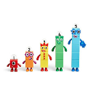 | Ordering and sequencing numbers | Ordering and sequencing events (language for time) | Addition within 10 | Addition within 20 | Subtraction within 10 and 20

