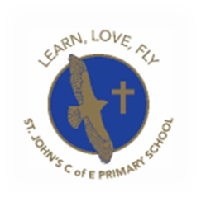
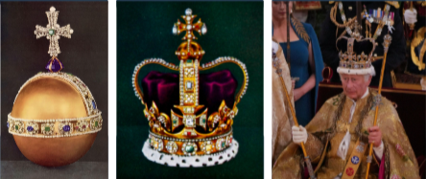
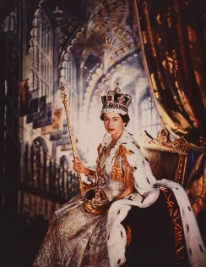
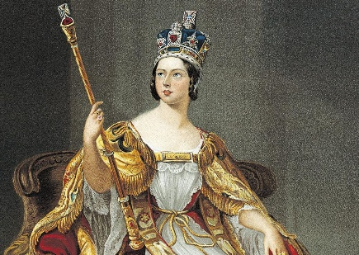
Learning Objectives in this unit:
History – Year 2 - Spring
What is a monarch?
Session 1 – What is a monarch?
- I can describe what a monarch is
Session 2 – Who is our monarch today?
- I can explain why coronations take place
Session 3 – When were Queen Victoria, Queen Elizabeth II and King Charles III crowned?
- I can record people, events and artefacts on a timeline
Session 4 – What can we tell about the life and times of Queen Victoria and Queen Elizabeth II from images?
- I can draw conclusions from evidence
Session 5 – How is Queen Victoria connected to St John’s?
- I can talk about local historical interactions with the monarchy
Session 6 – How has the monarchy changed?
- I can describe what is different and what is the same between Queen Victoria’s time and the time of King Charles III.
My Answer to our BIG QUESTION is:
What is a monarch?
______________________________________________________________________________________________________________________________________________________________________________________________________________________________

