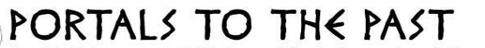
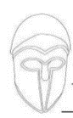

Dear Parents and Carers

We have exciting news! Portals to the Past will be visiting Year 3 on Monday 30th October between 9am and 3pm.

The total cost of the visit is £6.83

Please pay this to the school office by Monday 16th October. If you would like to pay this in instalments, please contact the school office to make arrangements.

Whilst this is a voluntary contribution, if we do not receive enough money to cover the visit, it will sadly have to be cancelled.

What to wear
We would like the children (and staff) to come dressed as an Egyptian. Please do not go to great expense over this but maybe be imaginative and see what you can make at home.

If you have any questions, please get in touch.

We are looking forward to a fun day ahead!

The Year 3 Team
Mr Moss, Mrs Bailey and Mrs Wray

FAO: Mr Moss, Mrs Bailey and Mrs Wray

I give permission for my child _________________________ in class ________
to attend the Portals from the Past visit on Monday 30th October 2023.

I enclose payment of £6.83

Signed ________________________________ Print name: _____________________________________

