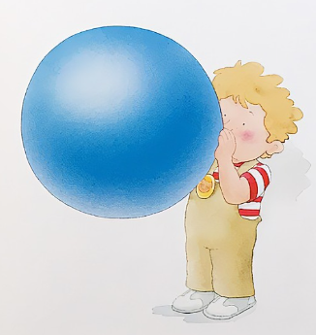
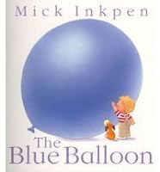
Early Years Home
Learning Project
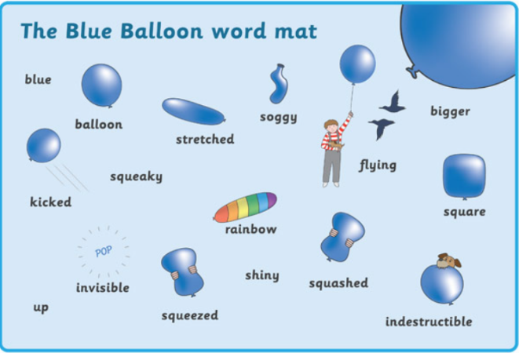

Dear Parents,
As part of our ‘Celebrations’ unit in school we have read ‘The Blue Balloon’. There is a link to the story on our website page in Year R if you want to listen to the story again.
Over the next couple of weeks, we would like your child to be as creative as possible with their attached balloon.
They may want to take it for a walk, turn it into a hot air balloon, turn it into a face or even add water and freeze something inside. Please could you take a photo and write a short description about what your child did. Please give these to your child’s teacher or email them over to: adminoffice@st-johns-gosport.hants.sch.uk with the Subject YEAR R PROJECT and they will be passed to us.
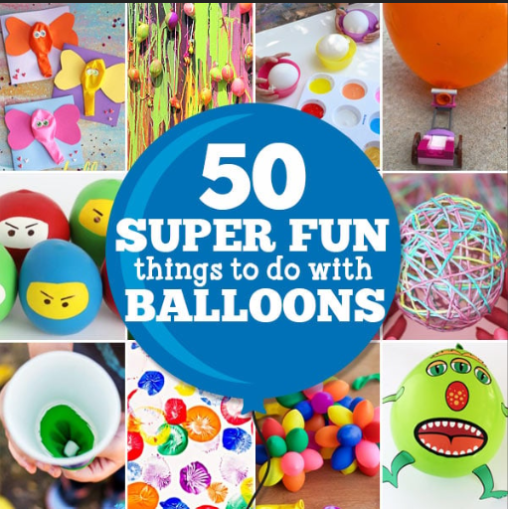
We would like these in by Friday 2nd February.

We can’t wait to see what you do!
Mrs Dickinson and Miss Hiseman


